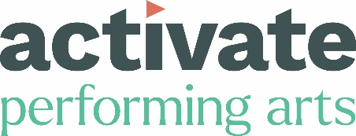

Access Guide – Weymouth 2026

Installation: Thursday 24th – Saturday 26th September 2026, 6pm-10pm, Westham Bridge
Drawing workshop: Friday 25th September 2026, 5pm-6pm.
Yoga workshop: Saturday 26th September 2026, 5pm-6pm.
Dance performance: Saturday 26th September 2026, 6.45pm-7pm

This Access Guide is produced by Activate Performing Arts and aims to inform and support audiences planning to attend Dusk Til Dark in Weymouth 2026. The guide contains information about accessing our events and the facilities available to audiences onsite. All events will have a dedicated Information Point if you have any questions on the day or you can contact us if you have any further questions or feedback.

Hard copies of all our print materials are available upon request.

Table of Contents
Introduction 3
Grading Key 4
WAVE by Squidsoup 5
Drawing Workshop by Yollande Posthumus 6
Yoga Workshop by Leslie Kelly 7
Dance Performance by DYD and The Originals 8
Site Information 9
Parking 9
Accessible Toilets 9
Food and drink 9
What to Bring 9
General Information 10
Visual Story 10
Contact Details 11

Introduction
Wave by Squidsoup will take place on Westham Bridge, from Thursday 24th September to Saturday 26th September 2026.
The installation is open from 1800-2200 daily.

Westham Bridge, Radipole Lake, Weymouth DT4 7DW
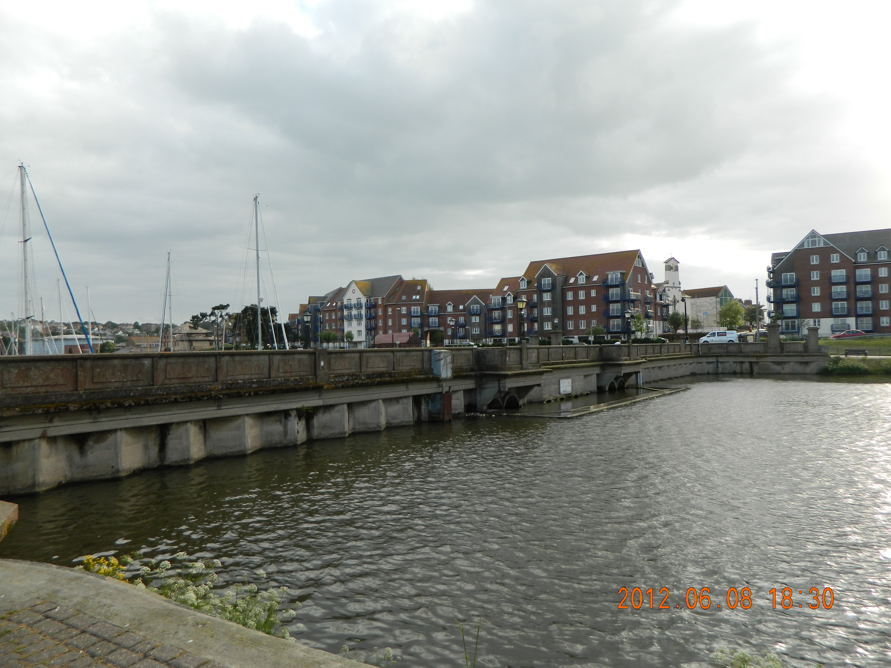

Grading Key

The following coding system has been used where possible, detailed descriptions on each site are also included. The information included in this guide is to help audience members decide how they access the event sites.

Gentle to moderate gradients with reasonably level surfaces. Path surfaces include tarmac, short grass and firm compacted gravel. No narrow gaps, steps or other access restrictions. Suitable for some wheelchair and mobility scooter users, but assistance may be required on some slopes and surfaces.
1
2
Moderate gradients with uneven surfaces. Long grass and uneven surfaced paths with loose gravel, and larger sized stones. No narrow gaps, steps or other access restrictions. Suitable for users of some all-terrain mobility scooters.

Steep gradients or paths with narrow, uneven surfaces. Long grass, un-surfaced paths with larger diameter loose gravel, bare earth, exposed tree roots and large stones. Narrow gaps including bridges, steps and other access restrictions. Not suitable for wheelchair or mobility scooter users.
3

WAVE by Squidsoup

Wave by Squidsoup is an immersive outdoor installation of suspended glowing orbs with changing light and sound. Audiences can walk through and around the artwork, or view it from the bridge area.

Type of Event: Sound and light installation, with audience invited to move around the static installation at their own pace.
1
Grading Key:

Terrain: hard-standing, pavement with dropped curbs, road closures in place. Car parking is suspended on the bridge.

Duration: Open for 4 hours per evening. Audience can come and go as they wish.

Seated/ standing: Standing. You are welcome to bring folding chairs if you wish.

Designated Access Area:
There is no dedicated accessible viewing area as audience members can move around and through the installation at their own pace.

Sudden Loud noises and Lighting effects: No. The sound is quiet and ambient, and lighting changes are subtle and sustained.

Drawing Workshop by Yollande Posthumus
Friday 25th September 2026; 1700-1800
Type of event: A relaxed drawing session inspired by Wave, the sound and light installation on Westham Bridge.
What to expect:
- Playful sketching exercises and prompts you can tackle at your own pace.
- There will be options for individual sketching and group sketching. You can take away your sketches or leave them for others to add to or edit.
- A relaxed and welcoming atmosphere
- No experience necessary.
- All resources will be provided.
1
Grading Key:

Terrain: hard-standing, pavement with dropped curbs, road closures in place. Car parking is suspended on the bridge.

Duration: One hour; 1700-1800. Participants can come and go as they wish.

Seated/ standing: Standing. You are welcome to bring folding chairs if you wish.

Designated Access Area:
There is no dedicated accessible viewing area as audience members can move around and through the installation at their own pace.

Sudden Loud noises and Lighting effects: No. The sound is quiet and ambient, and lighting changes are subtle and sustained.

Yoga Workshop by Leslie Kelly
Saturday 26th September 2026; 1700-1800
Type of event: Take a moment to pause, stretch and breathe beneath Wave, the light and sound installation on Westham Bridge.
What to expect:
- Suitable for all abilities
- Verbal and visual cues by the instructor, including a range of movement options
- As the session takes place directly on the bridge surface, participants are encouraged to bring a yoga mat and additional padding, such as a blanket or towel, for extra comfort.
- Leslie will offer a range of approaches to each pose, but participants take part at their own risk and should manage injuries accordingly.
- Yoga mats will not be provided, so please bring your own mat, picnic blanket or towel.
- All abilities and levels of experience are welcome.
- Families are welcome to attend together.

1
Grading Key:

Terrain: hard-standing, pavement with dropped curbs, road closures in place. Car parking is suspended on the bridge.

Duration: One hour; 1700-1800. Participants are encouraged to stay for the whole session but can come and go as they wish.

Seated/ standing: Standing/using a yoga mat. Please bring a yoga mat and additional padding. You are welcome to bring folding chairs if you wish.

Designated Access Area:
There is no dedicated accessible viewing area as audience members can move around and through the installation at their own pace.

Sudden Loud noises and Lighting effects: No. The sound is quiet and ambient, and lighting changes are subtle and sustained. Leslie will use a wireless microphone to project their voice through the space.

Dance Performance by Dorset Youth Dance and The Originals
Saturday 26th September 2026; 1845-1900

Type of Event: A dance performance by Dorset Youth Dance Company and The Originals, under the sound and light installation.
1
Grading Key:

Terrain: hard-standing, pavement with dropped curbs, road closures in place. Car parking is suspended on the bridge.

Duration: 15 minutes. Audience members can come and go as they wish.

Seated/ standing: Standing. You are welcome to bring folding chairs if you wish.

Designated Access Area:
There is no dedicated accessible viewing area for this short performance.

Sudden Loud noises and Lighting effects: No. The sound is quiet and ambient, and lighting changes are subtle and sustained.

Site Information

Parking
Nearest Blue Badge parking is:

Melcombe Regis car park (DT4 7DW) has 11 disabled parking spaces and is approximately 100m from the event. Carpark is pay and display, free after 6pm.

Swannery car park (DT4 7TY) has 27 disabled parking spaces and is approximately 300m from the event. Carpark is pay and display, free after 6pm.

Accessible Toilets
Swannery Public Toilets (Weymouth Town Council)
- Location: Radipole Park Drive, Weymouth, DT4 7TY
- Opening Hours: Daily, 9:00 AM – 9:00 PM (summer hours)
- Features: Wheelchair accessible

A Changing Places toilet is available at Weymouth Beach control office, King’s Statue (9am – 5pm). Access can be obtained via the Weymouth Beach control office.

Food and drink
There are a number of cafés and restaurants across the event site in Weymouth. For more information visit www.weareweymouth.co.uk.

What to Bring
All events are outdoors, so please dress appropriately for the changing weather and time of day and bring a water bottle.

All of the activities are chilled performances. A chilled performance takes a more casual approach to noise and movement in the performance space, but the performance itself is unchanged. We always have friendly staff and volunteers on hand if you have any questions.
General Information

Visual Story
We have a Visual Story available for this event on our website.

Contact Details

Contact: Jenna Hubbard, Producer (Outdoor Arts, Festivals and Touring)
Office: 01305 260954
Email: jenna@activateperformingarts.org.uk
Address: Activate Performing Arts, 7-9 The Little Keep, Bridport Road, Dorchester, DT1 1SQ
We aim to respond to all access enquiries within 2 working days, but there may be a delay during the event period 22nd-27th September 2026 whilst we are running the events.

Funders and supporters:

Special thanks to Headline Sponsor We Are Weymouth (Weymouth BID).
Core funded by Arts Council England, and Dorset Council.

