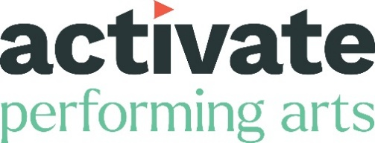

JOB OPPORTUNITY
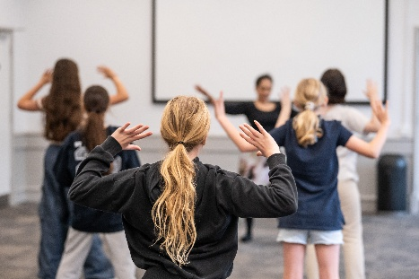

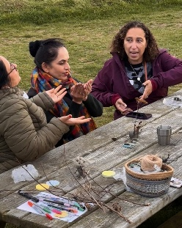
Producer (Theatre & Engagement)
Images (l-r): Consequences workshop, photo by Lindsey Harris; Flavours workshop, photo by Irene Archibald; The Art of Belonging workshop, photo by Jayne Jackson.

Activate Performing Arts is seeking an experienced Producer to lead on Theatre and Engagement.

We believe extraordinary moments connect and uplift us all. Our mission is to create opportunities for everyone through the performing arts. We are looking for a Producer to work with our team in Dorset and lead on Theatre and Engagement.

Working as part of our Producing team, you’ll be our lead Producer for Theatre and Engagement, with a key role in the Inside Out Dorset festival, you will also be part of the core team on talent development and artist support.

Within the Activate team, we have a female leadership and a broad mix of people with lived experience of caring responsibilities, disability/long-term health conditions and being from a working-class background. To read more about our Team go to: www.activateperformingarts.org.uk/meet-the-team/

We particularly welcome applications from people who have experienced barriers or prejudice relating to their age, gender identity, ethnicity and/or having a disability or long-term health condition, their sexuality, or being from a working class/ low-income background. We are keen to address under-representation in our team, through positive action in our recruitment.

Activate is core funded by:
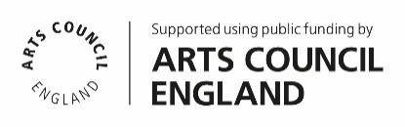

The Basics ____________________________________

Reports to: Artistic & Executive Director

Location: Hybrid working optional, note however, regular time in Dorchester office is essential and out on-site around Dorset (with travel across the UK expected).

Deadline: Tuesday 28th April 2026 at 12:00 midday

Interviews: Thursday 7th May 2026

Ideal start: As soon as possible.

Working days: 2.5 days per week, flexitime

Salary: £31-33,000 pro-rata depending on ‘ ‘ experience

Pension: Pension enrolment after 3 months’ continuous employment

Holiday: 23 days pro rata plus public holidays

Term: Permanent

To apply: Online application form. You can submit answers in alternative formats such as video and audio using the application form.

Informal conversation
Our Artistic & Executive Director, Kate Wood and Executive Producer Jen Walke-Myles are available for an informal conversation about the role, if you have any questions. Please contact us by email info@activateperformingarts.org.uk or call 01305 260954 to arrange.

About Us _____________________________________

Activate Performing Arts is a Dorset based charity that has been producing transformational programmes across the county for 35 years. We celebrate Dorset and promote our natural landscape and sense of place. Some of Dorset’s most remarkable urban and rural spots are transformed with experiences that touch hearts and minds like nothing else. At the heart of what we do is a belief that performing arts should be accessible for all – no matter what your experience or background.

We exist to promote, support and produce performing arts projects in our communities. Bringing world-class events to unexpected places, like town centres, village squares, beaches and hilltops.

Our aim is to break down barriers and reach the widest possible audiences, while celebrating our natural landscape and sense of place.

Supporting our performing arts community is at the heart of everything we do. We bring people together, offer advice, and provide access to learning and resources. We’re here to help creatives at all levels on their journey towards creating outstanding, inspiring work. We offer one-to-one free advice sessions and run training programmes for artists working in the performing arts as well as Chair the Dorset Theatre Promoters Consortium and Co-chair the Regional Engagement Network.

We run an inclusive performance group for children and young people called The Remix, and our Dorset Youth Dance company offers contemporary classes for 7–18-year-olds wanting to pursue their passion. We offer regular schools’ engagement and are a partner in the local cultural education partnership. We have a long-standing relationship with the Dorset National Landscape, where we work together on increasing access to landscape and the arts.

Activate is the producer of Inside Out Dorset, an international outdoor arts festival that takes place across the county every two years. The unique festival model presents a series of events across the conurbation, engaging with a socially diverse audience, and all the activities (workshops, installations, performances, talks) are free to attend. Our expertise is in presenting live events in sensitive landscapes, raising awareness of their environmental importance. We highlight the relationship between landscape, artists, land stewards and the climate emergency. We are now members of the Without Walls Artistic Directorate, Circostrada, and Outdoor Arts UK (OAUK).

We also produce and tour the work of 3 Dorset based companies: Lorna Rees Company, Tilly Ingram Theatre and The Working Boys Club to festivals and events in the UK and occasionally internationally.

Most recently, this role has led on the following projects here at Activate: the Dorset Theatre Promoters Consortium (DTPC), Nature Calling Engagement work in Dorset, River of Hope engagement work, The Arts of Belonging workshops and Flavours.

Activate is a National Portfolio Organisation funded by Arts Council England and we receive core funding from Dorset Council and BCP Council.

About You ____________________________________

Essential things we are looking for are below.

You will have:

Knowledge/ Skills
- Knowledge of contemporary theatre and outdoor arts practice and producing
- At least 5 years’ experience of producing in professional and community settings
- Experience of and demonstrable commitment to best practice in engagement within a range of settings
- Enthusiasm and understanding of working in an outdoor context
- Excellent organisational, project management and administrative skills
- Friendly and the ability to communicate confidently
- Ability to remain calm in busy periods
- Strong people management skills and good team working
- Ability to self-organise and take initiative, prioritise workload and manage multiple deadlines
- Enthusiasm for delivering professional development opportunities
- Ability to liaise with technical staff and artists
- Broad knowledge and understanding of contemporary arts structures, funding and wider public sector
- Flexibility and readiness to contribute to other jobs as required.

Management
- Proven ability to develop practical projects to deliver strategic priorities
- Experience of line managing freelance contractors
- Experience of successful fundraising from national, regional and local sources
- Experience managing complex partnerships and stakeholder relationships
- Proven financial and budget management experience
- Proven commitment to partnership and collaborative working.

General
- Dynamic and enthusiastic approach to work
- Understanding and commitment to best practice in Equity, Diversity and Inclusion
- Ability to work unsocial hours when needed
- Digital fluency: good working knowledge of MS Office and social media
- Driving licence
- You will need to live in Dorset/Bournemouth/Christchurch/Poole, or very near and will need a vehicle due to the limited rural transport infrastructure in the county.

Desirable: not essential, but a bonus for us would be for you to have:

- Experience in delivering a professional development programme for artists
- Knowledge of evaluation principles and techniques
- Experience of working in a voluntary/charitable organisation
- Understanding of the needs of working across an urban and rural region

We particularly welcome applications from people who have experienced barriers or prejudice relating to their age, gender identity, ethnicity and/or having a disability or long-term health condition, their sexuality, or being from a working class/ low-income background.

Job Description ________________________________

Job Title: Producer (Theatre & Engagement)
Job Purpose: To produce a developmental programme to enhance
our work in theatre, outdoor arts and engagement, and
contribute to Dorset creatives’ development in collaboration
with the team at Activate.

Reports to: Artistic & Executive Director, Activate

Line manages: Project Management staff depending on funding

Job Duties & Responsibilities

Main Duties

- To support the development of land based, outdoor practice, in our engagement work contributing to the development of our Inside Out Dorset festival
- To devise and plan imaginative and sustainable participatory, education and engagement projects, with partners
- To offer support to promoters across the county area through the Dorset Theatre Promoters Consortium (DTPC)
- To support the communication network for theatre locally, by promoting opportunities through the For Creatives e-news
- Play a role in creatives’ development with the team, specifically theatre makers and engagement practitioners
- Lead on fundraising for engagement programmes
- Liaise with key partners
- Act as an excellent advocate for Activate.

Producing

- Take a lead role in the producing of engagement and theatre projects with the Artistic Directors
- Nurture relationships with multiple partners
- Work closely with the Artistic Directors/team and partners to identify project needs
- Manage day to day relationships with artists and co-ordinate plans with other team members such as administration and marketing
- Plan the delivery of professional development for creatives
- Feed into our audience development plan
- Work with the team to draw together and contribute to the overall and individual project budgets
- Take the lead on evaluating and reporting on engagement projects to stakeholders.

Organisational

- Facilitate communication between all programme and local partners
- Contribute to audience facing communications
- Liaise with advisors and partnership groups in project development and delivery
- Line manage project assistants as and when necessary
- Oversee bookkeeping, budget management and financial reporting of your project areas
- Oversee contracting
- Oversee booking of accommodation and travel
- Oversee risk assessments and access audits
- Work closely with the Marketing & Communications Manager and Executive Producer on the preparation and planning of evaluation and advocacy
- Ensure effective and safe working practices at all times in line with Activate core policies, safeguarding children and vulnerable adults, equal opportunities, health and safety, environmental and diversity policies
- Report to stakeholders and ensure effective communication within the team including various partnerships
- Contribute to ongoing reporting expected as a publicly funded organisation
- General administrative support and event planning work.

How to apply _________________________________

A BSL version of this pack is available at www.activateperformingarts.org.uk/jobs/producer-theatre-and-engagement

To apply please complete the application form: https://form.jotform.com/260534450940352.

You can submit answers in alternative formats such as video and audio using the application form.

If you have any access requirements or need any help with your application, please contact us below and we will be happy to help.

If you would like this pack in another format such as Large Print, we will happily arrange this for you or if you need further information, please contact info@activateperformingarts.org.uk or call 01305 260954

Candidates are also required to complete an Equality of Opportunity questionnaire: https://www.surveymonkey.com/r/9RY3B6K
Note – this survey does not form any part of the recruitment selection process and is held in confidence according to our privacy statement.

Closing Date: Tuesday 28th April 2026 at 12:00 midday

Interviews: Thursday 7th May 2026

Equity & Diversity _____________________________

- We wholeheartedly support equal opportunities in all areas of our work. We strive to be a bold organisation that listens to the communities we work with. We encourage feedback on our services and how we can improve.

- We are committed to removing barriers. We oppose all forms of unlawful discrimination in relation to the protected characteristics. We are committed to having a staff and board that reflects and represents all sections of the community we serve and eliminating discrimination that is unlawful under the Equality Act 2010.

- We will guarantee an interview to any D/deaf or disabled candidate who fulfils the essential criteria for the role – please tell us in your application form or video. We are open to proposals of ways this role might be undertaken if our proposed structure presents barriers to any applicant.

- The interview panel will be representative of a diverse range of individuals.

- Application forms will be anonymised for short-listing.

