
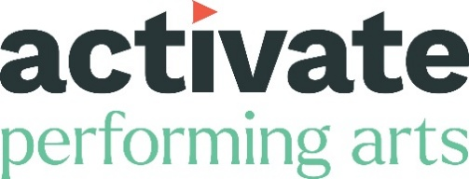

JOB OPPORTUNITY
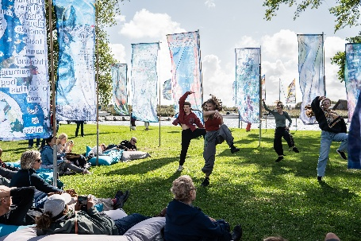
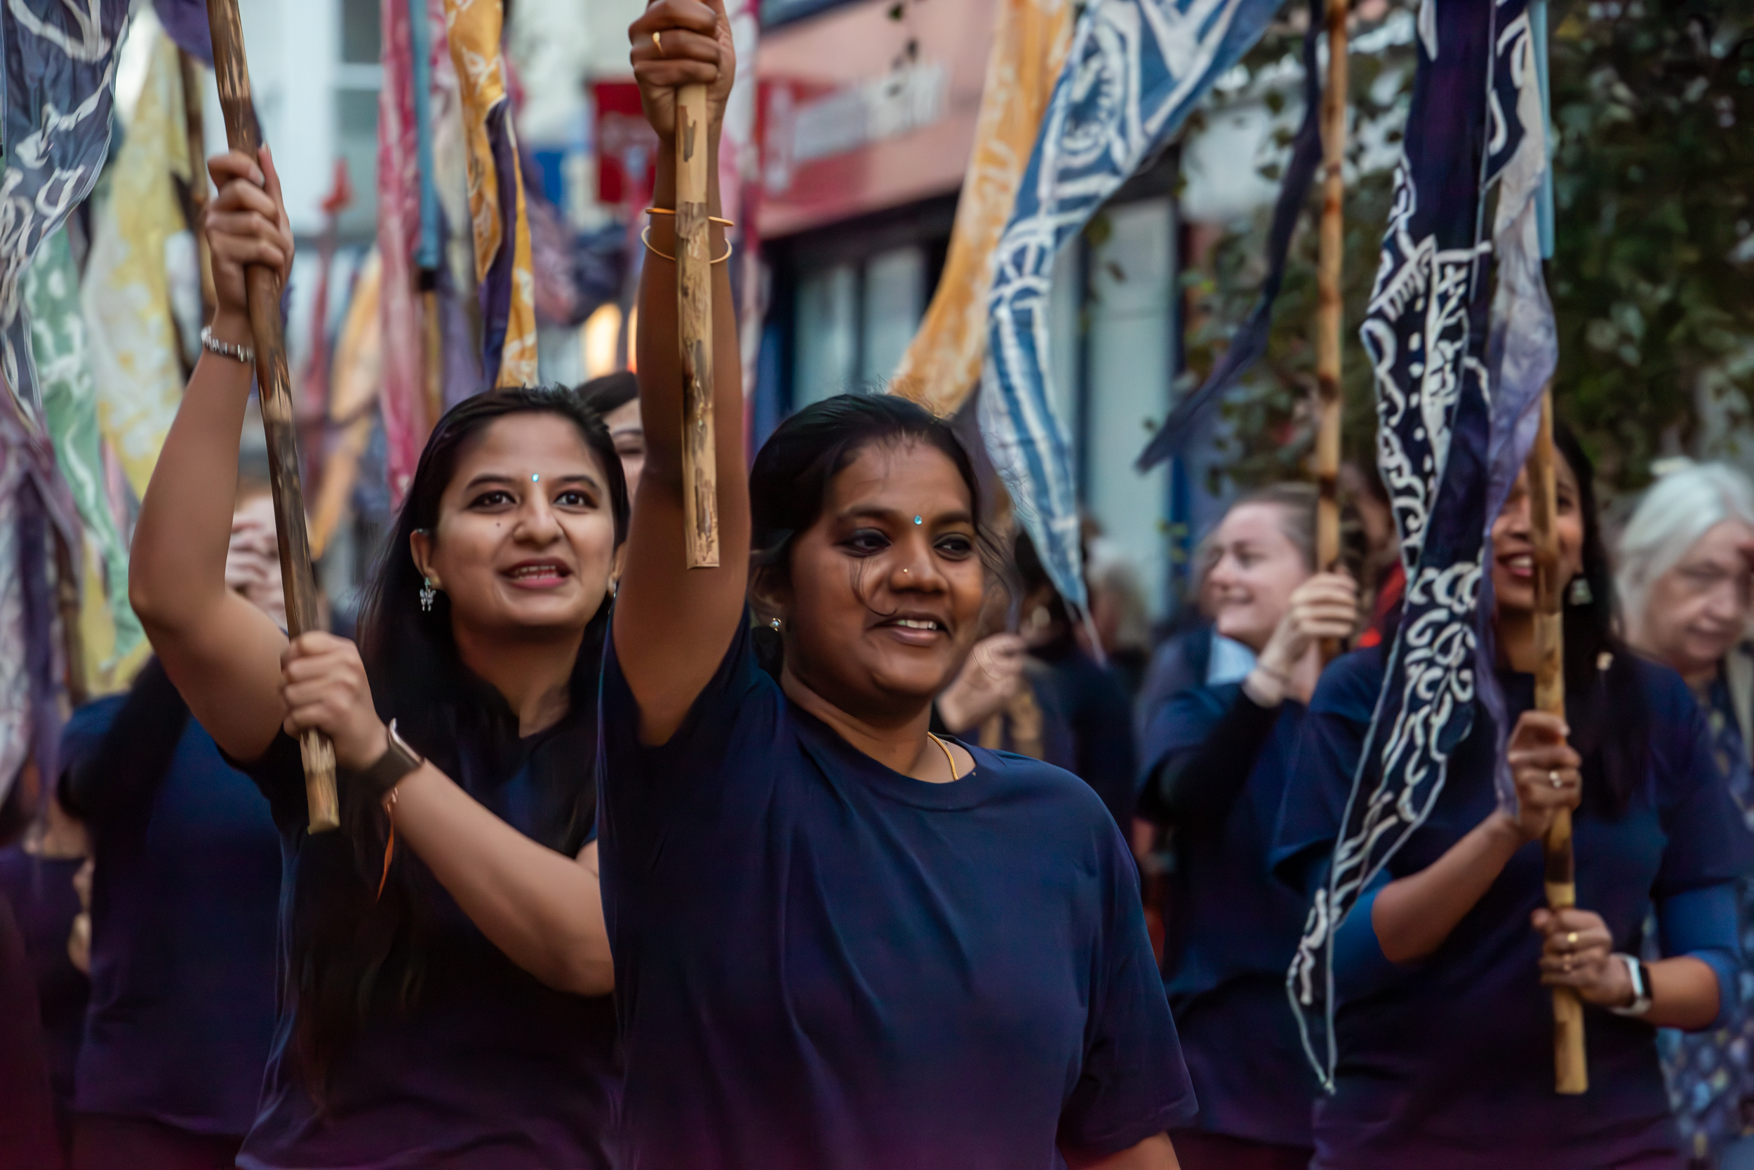
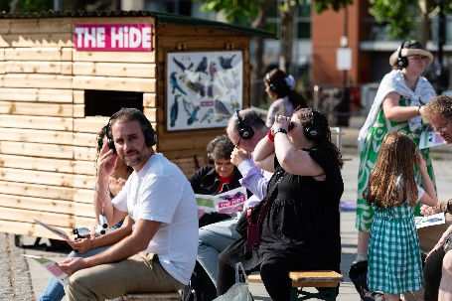
Producer (Outdoor Arts, Festivals, Touring)

Images left to right: Sonnet of Samsara; Attakkalari & Kinetika, Inside Out Dorset 2025 photo by Sam Rose. Dorset Youth Dance, Inside Out Dorset 2025 photo by Jayne Jackson, Tilly Ingram; Hide photo by Certain Blacks Ensemble 2025

Activate Performing Arts is seeking an experienced Producer to lead on outdoor arts, festival and touring.

We believe extraordinary moments connect and uplift us all. Our mission is to create opportunities for everyone through the performing arts. We are looking for a Producer to work with our team in Dorset and lead on Outdoor Arts, Festivals and Touring.

Working as part of our Producing team, you’ll be our lead Producer for our international outdoor festival: Inside Out Dorset and our outdoor events. You will have a key role with our core team on talent development and artist support including being the lead producer for our touring work.

Within the Activate team, we have a female leadership and a broad mix of people with lived experience of caring responsibilities, disability/long-term health conditions and being from a working-class background. To read more about our team go to: www.activateperformingarts.org.uk/meet-the-team/
We particularly welcome applications from people who have experienced barriers or prejudice relating to their age, gender identity, ethnicity and/or having a disability or long-term health condition, their sexuality, or being from a working class/ low-income background. We are keen to address under-representation in our team, through positive action in our recruitment.

This pack is available in BSL and we can provide a BSL interpreter for interview.

The Basics ____________________________________

Reports to: Artistic & Executive Director

Location: Hybrid working optional, regular time in Dorchester office essential and out on site around Dorset (with travel across the UK expected)

Deadline: Monday 5th January 2026 at 12:00 midday

Interviews: Thursday 13th January 2026

Ideal start: As soon as possible

Working days: 5 days per week, flexitime (if you are interested in a job-share we will need you to apply with another candidate)

Salary: £31-33,000 depending on experience

Pension: Pension enrolment after 3 months’ continuous employment

Holiday: 23 days plus public holidays

Term: Permanent

To apply: Online application form. You can submit answers in
alternative formats such as video and audio using the application form. We will interpret application videos sent in BSL.

Informal conversation

Both our Executive & Artistic Director, Kate Wood and Executive Producer, Jen Walke-Myles are available for an informal conversation about the role, if you have any questions. We are open to proposals of ways this role might be undertaken if our proposed structure presents access barriers to any applicant.

Please contact us by email info@activateperformingarts.org.uk or call 01305 260954 to arrange.

About Us _____________________________________

Activate Performing Arts is a Dorset based charity that has been producing transformational programmes across the county for over 30 years. We celebrate Dorset and promote our natural landscape and sense of place. Some of Dorset’s most remarkable urban and rural spots are transformed with experiences that touch hearts and minds like nothing else. At the heart of what we do is a belief that performing arts should be accessible for all – no matter what your experience or background.

We exist to promote, support and produce performing arts projects in our communities. Bringing world-class events to unexpected places, like town centres, village squares, beaches and hilltops.

Our aim is to break down barriers and reach the widest possible audiences, while celebrating our natural landscape and sense of place.

Supporting our performing arts community is at the heart of everything we do. We bring people together, offer advice, and provide access to learning and resources. We’re here to help creatives at all levels on their journey towards creating outstanding, inspiring work. We offer one-to-one free advice sessions and run training programmes for artists working in the performing arts.

We run an inclusive performance group for children and young people called The Remix, and our Dorset Youth Dance company offering contemporary classes for 5–25-year-olds wanting to pursue their passion.

Activate is the producer of Inside Out Dorset, an international outdoor arts festival that takes place across the county every two years. The unique festival model presents a series of events across the conurbation, engaging with a socially diverse audience, and all the activities (workshops, installations, performances, talks) are free to attend. Our expertise is in presenting live events in sensitive landscapes, raising awareness of their environmental importance. We highlight the relationship between landscape, artists, land stewards and the climate emergency.

We also produce one-off ‘signature events’ such as an annual ‘Dusk Til Dark’ celebration for We Are Weymouth (funding dependent), in the alternate years to the festival and other national moments such as Dorset Moon in 2019 and Green Space Dark Skies for Walk the Plank in 2022.

We also produce and tour the work of 3 Dorset based companies: Lorna Rees Company, Tilly Ingram Theatre and The Working Boys Club to festivals and events in the UK and occasionally internationally.

Activate is committed to safeguarding and promoting the welfare of children, young people and vulnerable adults.

Activate is a National Portfolio Organisation funded by Arts Council England and we receive core funding from Dorset Council and BCP Council.

About You ____________________________________

Essential things we are looking for are below.

You will have:

Knowledge/ Skills
- Experience of producing in an outdoor/festival context
- Enthusiasm and understanding of outdoor arts, festivals and site-specific work
- Relevant art form knowledge
- Experience of successful fundraising from national, regional, international and local sources
- Excellent organisational, project management and administrative skills
- Friendly and confident communication ability
- Enthusiasm for delivering professional development opportunities
- Ability to self-organise and take initiative, prioritise workload and manage multiple deadlines
- Ability to remain calm in busy periods
- Flexibility and readiness to contribute to team tasks as required
- Strong people management skills and good team working
- Ability to liaise with technical staff and artists
- Understanding and proven commitment to the arts in supporting social and economic benefit
- Broad knowledge/understanding of contemporary arts industry and funding and the wider public sector.

Management
- Proven ability to develop practical projects to deliver strategic priorities
- Experience of line managing freelance contractors
- Experience managing complex partnerships and stakeholder relationships
- Financial and budget management experience
- Lead on reporting to funders
- Proven commitment to partnership and collaborative working.

General
- Dynamic and enthusiastic approach to work
- Understanding and commitment to best practice in Equity, Diversity and Inclusion
- Ability to work unsocial hours when needed
- Digital fluency: good working knowledge of MS Office and social media
- Driving licence.

You will need to live in Dorset/Bournemouth/Christchurch/Poole, or very near and will need a vehicle due to the limited rural transport infrastructure in the county.

Desirable i.e. not essential, but a bonus for us would be for you to have:

- Experience in delivering a professional development programme for artists
- Knowledge of evaluation principles and techniques
- Experience of working in a voluntary/charitable organisation
- Understanding of the needs of working across an urban and rural region
- Understanding of the local area.

We particularly welcome applications from people who have experienced barriers or prejudice relating to their age, gender identity, ethnicity and/or having a disability or long-term health condition, their sexuality, or being from a working class/ low-income background.

Job Description ________________________________

Job Title: Producer (Outdoor Arts, Festivals, Touring)

Job Purpose: To produce our outdoor programme, events (including Inside Out Dorset), touring and contributing to artists’ development in collaboration with the team at Activate.

Reports to: Artistic & Executive Director, Activate

Line manages: Assistant Producer, Production Manager, Volunteer Manager, Access Co-ordinator (all Freelance).

Job Duties and Responsibilities

Main Duties

- Plan and deliver the biennial festival programme and signature events, including engagement, participation and inclusion with the Artistic Directors, the Theatre, Education and Engagement Producer and Activate Team,
- Act as touring Producer for a small cohort of companies Activate represents, pitching shows to promoters and booking touring calendars
- Play a role in creatives’ development with the team
- Lead on resource development for the outdoor programme
- Liaise with key partners
- Act as an excellent advocate for Activate.

Producing

- Take a lead role in the producing of outdoor projects with the Artistic Directors
- Nurture partner relationships with multiple venue and programme partners
- Work closely with the Artistic Directors to identify project needs
- Manage day to day relationships with artists and co-ordinate relationships with other team members such as administration (visas and invoices), production and marketing
- Plan the delivery of professional development for creatives
- Work with the team to draw together the overall and individual project budgets.

Organisational

- Facilitate communication between all programme and local event partners
- Contribute to audience facing communications
- Liaise with advisors and partnership groups in project development and delivery
- Line manage Assistant Producer and be responsible for freelance Head of Health & Safety/Production Manager and staff, such as Access lead, Volunteer Co-ordinator/s
- Identify sub-contractors and suppliers to deliver programming activities where relevant
- Oversee bookkeeping, budget management and financial reporting
- Oversee contracting, license applications, permissions, work permits and insurances
- Oversee booking of accommodation and travel
- Manage relevant volunteer co-ordination
- Oversee access audits
- Work closely with the Marketing & Communications Manager and Executive Producer on the preparation and planning of evaluation and advocacy
- Ensure effective and safe working practices at all times in line with Activate core policies, safeguarding children, equal opportunities, health and safety, environmental and diversity policies
- Report to stakeholders and ensure effective communication within the team including various partnerships
- Contribute to ongoing reporting expected as a publicly funded organisation
- General administrative support and event planning work.

How to apply _________________________________

A BSL version of this pack is available at https://activateperformingarts.org.uk/jobs/producer-outdoor-arts

To apply please complete the online application form.

You can submit answers in alternative formats such as video and audio using the application form.

If you have any access requirements or need any help with your application, please contact us (details below) and we will be happy to help.

If you would like this pack in another format such as Large Print, we will happily arrange this for you or if you need further information, please contact info@activateperformingarts.org.uk or call 01305 260954.

Closing Date: Monday 5th January 2026 at 12:00 midday

Interviews: Thursday 13th January 2026

Equity & Diversity _____________________________

- We wholeheartedly support equal opportunities in all areas of our work. We strive to be a bold organisation that listens to the communities we work with. We encourage feedback on our services and how we can improve.

- We are committed to removing barriers. We oppose all forms of unlawful discrimination in relation to the protected characteristics. We are committed to having a staff and board that reflects and represents all sections of the community we serve and eliminating discrimination that is unlawful under the Equality Act 2010.

- We will guarantee an interview to any D/deaf or disabled candidate who fulfils the essential criteria for the role – please tell us in your application form or video. We are open to proposals of ways this role might be undertaken if our proposed structure presents barriers to any applicant.

- The interview panel will be representative of a diverse range of individuals.

- Application forms will be anonymised for short-listing.

Activate is funded by:
