CREATE! 2026
  - Applicant Information Pack

January 2026

A free course on making artistic events happen
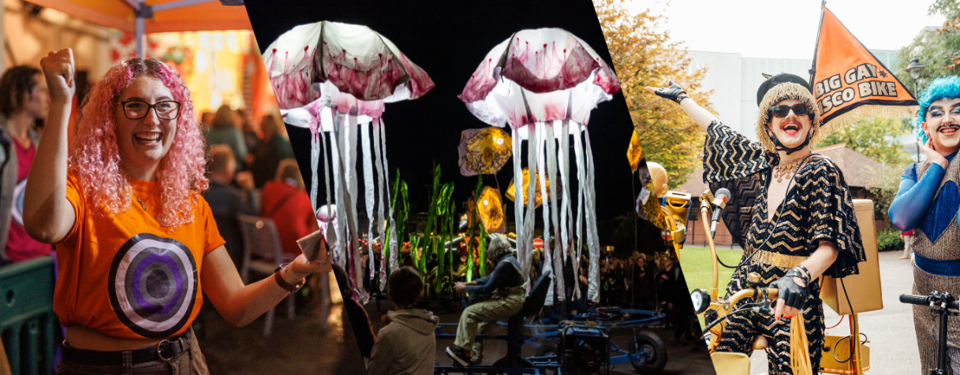

What is it?
CREATE! 2026 is a free course for those who are based in Dorset and BCP (Bournemouth, Christchurch and Poole) that would like to learn how artistic events are created from start to finish.

With workshops led by experienced professionals, the course will cover topics such as:
-What makes a great event?
-Building a network
-How do community-led projects work?
-Financing a creative idea
-Where can events happen?
-Identifying your audience
-What is risk management

Participants on the course will have an opportunity to prepare a pitch document for a creative idea that they have which the several arts organisations facilitating the course will provide feedback on. At the end of the course, you can choose to use this pitch document to bid for a pot of funding from the partner organisations that could help seed-fund your idea.

Held in January across different spaces in Dorset, participants will take part in the workshop sessions together, where there will be opportunities for connection with each other and space to see different types of artistic work that support your time both on the course and after.

DEADLINE FOR APPLICATIONS
Monday 27th October @ 5pm

What you will get from the course
- All travel / food expenses during the course are covered by us
- A clearer understanding of how artistic events can be made
- An opportunity to pitch for a small pot of money to help make your creative idea a reality
- Networking sessions during and after the course
- Direct access to arts professionals
- Support and resources signposted directly to you
- A new peer network of like-minded early career creatives.

This is a course for those of any age (18+) who may have some experience in creating their own creative events, those who are wanting to step into the artistic industry but don’t know how, and also those who have no idea how any of the creative world works but thinks they have a great idea they’d like to make a reality.
This is an experience for those who are wanting to grow as creative people, and it’s been curated by three local leading arts organisations:
- Activate Performing Arts (Producers of Inside Out Dorset)
- Arts by the Sea Festival
- b-side Festival.

Key dates and venues
Workshop dates and venues are currently being finalised, please check back regularly for more updates.

The course consists of 5 days, all on Fridays and Saturdays in January 2026, consisting of 4 workshop days, and a full day of site visits. The provisional dates are Friday 9th, Saturday 10th, Friday 16th, Friday 23rd and Friday 30th January TBC. Venues are deliberately spread out across Dorset and BCP on different days, and we will cover your transport costs and/or organise transport. Lunch and refreshments on all workshop days will be provided but you may need to bring a packed lunch for the site visits day (TBC).

The days will run between 10am and 4pm, with breaks included.

Access
Inclusion is at the heart of Activate, and all our partner organisations as we deliver CREATE! 2026.

We have an access budget which can be used on childcare costs, caring agency cost, assistance needs and more. This could range from scheduling in regular check-ins with you, to providing a BSL interpreter, documents in large print or different formats, or an access support worker to assist you e.g. take notes. We are on a journey to consider access at the inception of each event, to discover the creative potential of accessible practice, and find new ways to reach, work with, and offer opportunities to everyone.

This is no exception with CREATE! 2025, and each project partner is invested in curating an accessible course that can be catered to your individual needs from the point of application, up until the end of the course.

We will provide lunch and refreshments for all sessions (except for site visit day TBC) and are committed to catering for any allergies or dietary requirements.

Please feel free to contact Grace, Trainee Producer to discuss your access requirements and how we can make your time on the course easier on grace@activateperformingarts.org.uk or 01305 260954.

Course Content
Each day will be split into 2 x workshop sessions, looking at big topics in an easy to digest way. These sessions will also be split up with plenty of breaks, and time for questions and answers at the end.
Each workshop is participatory so that you’re able to take every opportunity to ask the questions you want to, or feel free to use the time to sit, listen, reflect and take notes.
CREATE! is about you using the space to learn in a way you feel most comfortable, and where each participant is able to take what they need from the course. To further supplement your time on the course, we will be signposting resources that may be useful to you in growing your knowledge outside of the workshop space.
DAY 1 – INTRODUCTIONS AND BUILDING KNOWLEDGE
Introductions
- Who are we?
- Who are you?
- What makes a great event?
Building Knowledge
- Where can events happen?
- Identifying your creative motivation
- Building the initial idea into something real
- Working with people and building a productive team
DAY 2 – FINDING YOUR AUDIENCE, RISK MANAGEMENT & ACCESS
Marketing & Identifying Audiences
- What can audiences look like?
- Where to find an audience?
- How to get your community involved
- Marketing in rural areas vs urban areas
Access & Risk Management
- Accessibility → Distilling a complex and important word into something simple
- Considering access and inclusion before, during and after production
- Identifying risk
- Why does safety make your events more fun?
- What happens when things go wrong and how do you plan for it?
DAY 3 – MAKING IT HAPPEN
Working in the Community
- What is a community?
- What is community-led work?
- Utilising the people and places around you to bring something special to life.
Money, Stakeholders & Funding Applications
- Different sources of finance and how to budget
- Where is the money?
- Where is money spent on a project and how do you manage the budget?
- Funding applications and how we frame ourselves when writing them.
PITCHING & FUNDING OPPORTUNITY
At the end of DAY 3, after you’ve looked at funding applications, how you write them and
how you manage a project budget, participants will be presented with a Pitch/Project
Planning Template. This is an opportunity for you to use what you’ve learned on the
course in order to pitch for a pot of money to help seed-fund your creative idea.

Participants will take this home with them and will have time to return the (optional) pitch to the project partners for evaluation. This will be a written pitch, but should you wish to submit the content in a different way (such as a video or audio recording), then you will be able to do so as long as the project partners can independently engage with it in under 5 minutes.
DAY 4 – FULL DAY OF SITE VISITS
Participants will be taken on a full day of site visits, exploring both rural and urban locations.
This will be an opportunity to practice in-person risk assessments and access consideration and put what you have learned into action.
DAY 5 – INDUSTRY Q+A, FEEDBACK & EVALUATION
Checking In: Time to talk about how you found pitching your creative idea. Recap on topics/points participants would like more clarification earlier on in the course.
Pitch feedback: Generic feedback will be offered to the group on their pitches, where the general strengths were and general areas for development. We will set aside time to be able to look at improving knowledge where we feel it to be necessary. Where pitches have not been successful, the partners will do our best to link you to other opportunities to help you make your idea a reality.
Guest Q&A: A varied panel of inspiring guest professional creatives working in a broad range of creative events will join the space to share insights into their own career path and how they work. We will hold a Q&A session for CREATE! participants with the panel.
Evaluation: Evaluate CREATE! 2025 as a group and talking about where participants might go next. Keeping in touch and future get together opportunities.

How to apply
If all of the above sounds good to you, and you’d like to get involved in CREATE! 2026, then take a look at the application instructions below and fill out the application form!
Please read the following selection criteria to help you with your application:
Essential criteria
• Creative ability to come up with original ideas
• Genuine passion for creating artistic events
• Willingness to learn and a curiosity for new experiences
• Good communication skills
• Less than 2 years working or volunteering in the arts sector OR less than 2 years since returning after a career break.
Desirable criteria
• Able to work both in a team and solo
• Awareness of gaps in your skills and/or knowledge.
APPLICATION FORM: https://form.jotform.com/jen467/create-2026-application-form
If you would like this pack in another format such as Large Print, we will happily arrange this for you or if you need further information, please contact grace@activateperformingarts.org.uk or call 01305 260954
If you would like to submit a video or audio application instead (max 5 mins), then please send it via Wetransfer to Grace via her email above.
Any questions? Get in touch.
The main thing we’d like to learn is why you would like to have a place on the course, your creative idea and a little bit about you as a person.
Key things to think about:
- A creative idea you’d potentially like to get off the ground at some point in the future.
- What interests you about the course?
- The access support we can offer you if you are offered a place on the course.

Terms & conditions
TERMS & CONDITIONS
By applying for a place on the course, you agree that:
- You will be over the age of 18 either on or before 9th January 2026.
- You must agree to attend all the sessions and dates specified in this document, unless mitigating circumstances arise.
- Participants on the course will be mindful of how they interact with others to help create a safe space for themselves and others during the course. We will make every effort to ensure that the working space is comfortable and an enjoyable place to learn and be.
- Participants will be expected to have a suitable level of engagement during the workshop days, so you can get what you need out of the course however you feel most comfortable (while engaging in the tasks and learning outlined during the course).
- Travel reimbursement will be paid to you after Activate have received your receipts, unless this delay creates a barrier for you or we are organising your transport.
- We understand how necessary these opportunities are for emerging creatives and wish we were able to offer everyone a place on CREATE! 2025, however we anticipate receiving a large amount of applications and will be unable to do so. By sending in an application, you agree that the Partner Organisations’ selection of participants is final and cannot be challenged.

Equality & diversity
• We wholeheartedly support equal opportunities in all areas of our work. We strive to be a bold organisation that listens to the communities we work with. We encourage feedback on our services and how we can improve.
• We are committed to removing barriers. We oppose all forms of unlawful discrimination in relation to the protected characteristics. We are committed to eliminating discrimination that is unlawful under the Equality Act 2010.
• We are open to proposals of ways this course might be undertaken if our proposed structure presents barriers to any applicant.

Who we are
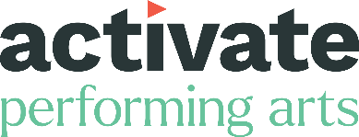
Activate Performing Arts
For over 30 years, we’ve been promoting, supporting and producing some of the most exciting events in the UK. We’re here to bring performing arts to as many people as possible. And give creatives the support they need to make outstanding work. We connect communities. We break down barriers. We celebrate our landscape. We pride ourselves on being open and working with others to make performing arts accessible for all. In everything we do, we have just two rules. Anything’s possible. And everyone’s invited. We are also producers of Inside Out Dorset which is an international outdoor arts festival that takes place across the county every two years. We celebrate Dorset and aim to promote our natural landscape and sense of place.
Arts by the Sea Festival

Arts by the Sea brings together large-scale spectaculars, diverse music, intriguing installations, dance, street theatre, participatory experiences and much more, in one unique and celebratory festival.
Originally launched in Bournemouth in 2011, Arts by the Sea’s main event takes place in Bournemouth town centre, but the festival has also hosted activity in Christchurch and Poole. We also bring cultural activity out into neighbourhoods, working with schools and communities across the area. We value our talented local artists and creatives and provide a variety of opportunities to support their development. We feel privileged to bring you inspirational experiences in one of the most beautiful locations in the country and put inclusivity, diversity and sustainability at the heart of everything we do.

b-side
b-side is an internationally recognised and locally loved arts organisation that both embodies and enriches its place of origin – the Isle of Portland in Dorset. Portland is the beating heart that inspires b-side’s work, but our projects and opportunities extend all over Dorset and beyond.
We work with and commission artists who are as excited by the bigger picture as the smallest detail. Our current ‘Common Lands’ programme regards Portland as a microcosm to explore relationships to and with land. We invite artists, residents, and researchers to create unique and inventive projects inspired by the themes of ‘people’ and ‘place’. We host big discussions on topics that affect us both locally and globally and create art that exists in unusual and unexpected places.

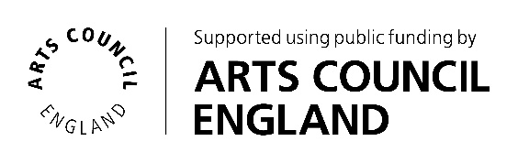
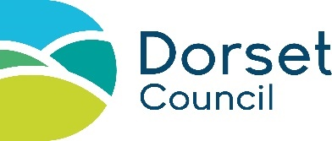
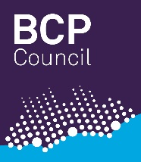

Lead Image credits: Left: b-side Festival Launch. Photo Paul Box. Middle: Inside Out Dorset 2022 presents Peixos by Sarruga. Photo Jayne Jackson. Right: Arts by the Sea 2023. Photo James Bridle.

